

Enhanced AI-Driven Intrusion Detection System for Detecting Modern Network Attacks

GROUP NUMBER 10
Student Name | Student ID
M.R.M.Asif | CT/2022/011
P.D.L.Shehan | CT/2022/012
K.G.Senarathna | CT/2022/060
O.K.Y.M.Karunarathna | CT/2022/074
M.N.F.M.Sajith | CT/2022/088

1. Project Background
1. Project Purpose and Significance
The purpose of this project is to develop an advanced, AI-based Intrusion Detection System that overcomes the limitations of traditional security tools. As digital infrastructure expands rapidly through IoT, cloud computing, and mobile apps, the significance of this project lies in its ability to protect organizations and individuals from increasingly sophisticated and frequent cyberattacks.
2. Context and Rationale
Why is this project necessary? Traditional IDS rely on signature-based detection, which is ineffective against unknown or "zero-day" attacks and cannot easily adapt to modern, dynamic network environments
What problem does it address? It addresses the critical need for systems that can detect threats within encrypted traffic (HTTPS, TLS, VPN) and identify rare but dangerous attack classes that are often overlooked.
Data and Evidence: Research shows that many current ML-based IDS rely on outdated datasets (like KDD Cup '99) that do not reflect modern traffic patterns, and they often require high computational resources, making them unsuitable for real-time deployment on smaller devices.
3. Previous Studies and Gaps
Historical Perspective: Early systems used fixed signatures of known threats. As threats evolved, researchers began applying supervised Machine Learning (SVM, Random Forest, kNN) to learn normal traffic patterns and detect anomalies.
Evolution of the Problem: With the rise of encryption, packet-payload inspection has become less effective, shifting the focus toward flow-level metadata.
Available Solutions and Gaps:
Encrypted Traffic: Few current systems explicitly target detection in encrypted flows; most still rely on payload inspection.
Rare Attacks: Detection for infrequent but critical attacks like Remote-to-Local (R2L) and User-to-Root (U2R) remains poor.
Resource Constraints: Deep learning models are often too computationally expensive for real-time use on IoT or edge devices.

4. Stakeholders and Beneficiaries
Organizations: To secure corporate networks against advanced persistent threats and data breaches.
Individual Users: To ensure privacy and security in an increasingly connected world.
Security Administrators: To receive accurate, real-time alerts and transparent, explainable insights (via XAI) into network anomalies.
IoT/Edge Infrastructure: Beneficiaries of a lightweight system that provides security without overwhelming resource-constrained hardware.

Paper Name | Methods / Approach | Key Results | Gaps
Al Lail, Garcia & Olivo (2023) – Machine Learning for Network Intrusion Detection: A Comparative Study [1] | Comparative evaluation of supervised ML algorithms such as SVM, Random Forest, and kNN on modern datasets. | Algorithms achieved strong accuracy on known attack classes and performed reliably on structured features. | Does not explore encrypted traffic, struggles with rare-class attacks, and lacks real-time evaluation.
Huang, Li & Zhang (2023) – Enhancing network security through machine learning: A study on IDS using supervised algorithms [2] | Decision Tree, Naive Bayes, kNN applied on CICIDS2017 with preprocessing and feature selection. | Achieved high accuracy on majority classes and demonstrated effective feature-based filtering. | Does not address minority-class attacks, encrypted or obfuscated flows, nor adaptive threats.
Rahman (2024) – A Sequential Deep Learning Framework for Robust NIDS [6] | Deep sequential models for intrusion detection evaluated on recent traffic datasets. | High detection rates and strong learning capability for complex traffic patterns. | Deep models require heavy computation and are unsuitable for low-resource or real-time deployments.
Shetty & Achar (2024) – Advanced Machine Learning Techniques in Network-Based IDS [7] | Review of ML-based IDS approaches with emphasis on datasets and evaluation standards. | Highlights strengths of ML for IDS and the need for realistic traffic conditions. | Confirms dataset limitations, lack of encrypted traffic handling, and insufficient testing on real-world networks.
Hnamte et al. (2023) – AE + LSTM Hybrid IDS for Modern Traffic [8] | Autoencoder plus LSTM hybrid on CICIDS2017 and CSECICIDS2018 datasets. | Shows strong multiclass detection and effective feature extraction for sequential traffic. | Still impacted by encrypted payload traffic, minor attack imbalance, and generalisation issues.

Summary of Identified Gaps
- Most recent works continue to rely on publicly available datasets such as CICIDS2017 and UNSW-NB15, which may not fully represent encrypted traffic or modern IoT-based network patterns [9], [10].
- Few systems explicitly target detection in encrypted traffic flows; payload-based detection remains the most common approach.
- Detection performance for rare or minor attack classes such as Remote-to-Local (R2L), User-to-Root (U2R), and zero-day attacks remains poor or is not evaluated thoroughly [11], [12].
- Deep learning models often achieve high accuracy, but their high computational cost reduces feasibility for real-time deployment on resource-limited devices.
- Explainability is rarely integrated, which limits understanding of model decisions in security contexts and complicates auditing.
These gaps highlight the need for our solution: a machine learning-based intrusion detection system that can process encrypted traffic, effectively detect both minor and major attack classes, and remain lightweight enough for practical real-time deployment.

Novelty of This Study:
This project proposes a lightweight, supervised machine learning-based IDS with the following specific contributions:
- Detection of malicious activity in encrypted traffic using flow-level features such as packet size, flow duration, inter-arrival time, and packet count, instead of payload inspection.
- Improved detection of minority attack classes (R2L, U2R) using data balancing techniques such as SMOTE (Synthetic Minority Over-sampling Technique) and class weighting.
- Development of a computationally efficient model by applying feature selection and dimensionality reduction, ensuring low inference time suitable for real-time environments.
- Integration of Explainable AI (XAI) using SHAP values to provide transparent and interpretable model decisions.

2. Project Objectives
1. Aim of the Project
The overall aim of this project is to develop an optimized, supervised machine learning-based Intrusion Detection System (IDS) capable of detecting malicious activities in modern network environments, including encrypted traffic, while maintaining computational efficiency for real-time deployment.
2. Breakdown of Objectives
Following the required action-oriented approach, the project is divided into the following five key objectives:
- Improve detection performance for minority attack classes (Remote-to-Local (R2L) and User-to-Root (U2R)) by increasing F1-score and recall compared to baseline models
- Achieve high detection accuracy (greater than 90% accuracy) for major attack classes while maintaining balanced model performance
- Ensure a low False Positive Rate (FPR) for normal network traffic to minimize false alarms
- Analyze and detect threats within encrypted network traffic using flow-level metadata without relying on payload inspection
- Reduce computational complexity by applying feature selection and dimensionality reduction, ensuring suitability for real-time deployment in resource-constrained environments

3. Methodology
3.1 Data Collection & Preprocessing
- Use NSL-KDD dataset as a baseline for training and evaluating classical intrusion detection performance.
- Use CICIDS2017 dataset to represent modern network traffic, including realistic attack scenarios and encrypted communication patterns.
- Perform data cleaning:
  - Remove duplicates and missing values
  - Handle inconsistent records
- Encode categorical features using one-hot encoding.
- Normalize numerical features using Min-Max Scaling or Standardization.
Encrypted Traffic Handling:
- Extract flow-level metadata using tools such as CICFlowMeter, including:
  - Flow duration
  - Total packets
  - Packet size statistics
  - Inter-arrival time
- Simulate real-time encrypted traffic using packet replay tools (e.g., Tcpreplay) in a Linux VM environment.
- Combine datasets into a unified format for training and testing.
3.2 Machine Learning Model Development
- Implement supervised machine learning algorithms:
  - Support Vector Machine (SVM)
  - Random Forest
  - k-Nearest Neighbours (kNN)
  - Decision Tree
  - XGBoost
- Perform multiclass classification:
  - Normal traffic vs multiple attack categories
- Apply feature selection techniques (e.g., correlation analysis, feature importance) to reduce dimensionality and improve efficiency.

3.3 Explainable AI (XAI) Integration
- Use XAI techniques (e.g. SHAP values, LIME, or feature importance charts) to interpret classification decisions. This will allow understanding which features contribute most to detection decisions—especially useful when dealing with encrypted traffic where payloads are unseen.

3.4 Training, Validation & Testing
- Split the combined dataset into 70 % training, 30 % testing.
- Use kfold crossvalidation on the training set for hyperparameter tuning and to reduce overfitting.
- Employ techniques to address class imbalance (e.g. oversampling minority classes, class weighting).

3.5 Evaluation Metrics and Performance Analysis
- Standard classification metrics: Accuracy, Precision, Recall, F1score.
- Special attention to Detection Rate (DR) for minor attack classes (e.g. R2L, U2R).
- False Positive Rate (FPR), confusion matrix, per class performance breakdown.
- Compare models (SVM, Random Forest, kNN, Decision Tree, XGBoost) to select the best performing one.

3.6 Deployment and Demonstration
- Deploy the chosen model in a Linux-based virtual machine (VM) configured to accept simulated real-time network traffic (e.g. via packet replay tools).
- Demonstrate live detection performance on both unencrypted and simulated encrypted traffic using flow metadata.
- Log detection events, show performance metrics, and use XAI output to interpret detected anomalies.

4. Deliverables
- Achieve high detection accuracy and improved F1-score for minority attack classes (R2L, U2R)
- Demonstrate effective detection of encrypted traffic using flow-level features
- Deploy a functional IDS system on a Linux VM with real-time traffic analysis
- Provide interpretable model outputs using XAI techniques

5. Budget

Category | Item Description | Quantity | Estimated Unit Cost (LKR) | Total Cost (LKR)
Documentation | Final Project Report Printing (Standard) | 3 Copies | 1200 | 3600
Documentation | CD/DVD for Digital Submission & Labels, | 2 | 200 | 400
Contingency | Internet Data & Miscellaneous Research Costs | - | 1500 | 1500
TOTAL |  |  |  | 5500

6. Timeline (6 Months)

Month | Activities
1 | Conduct detailed literature review; finalise project objectives; set up Linux VM environment; download and collect datasets (NSL-KDD, CICIDS2017, UNSW-NB15).
2 | Perform data cleaning and preprocessing; handle categorical/numerical features; normalise data; optionally begin simulated encrypted traffic capture and metadata extraction.
3 | Implement supervised ML models (SVM, Random Forest, kNN, Decision Trees, XGBoost); prepare training scripts; set up cross validation and hyperparameter tuning.
4 | Train models; tune hyperparameters; handle class imbalance; implement Explainable AI modules (SHAP/LIME).
5 | Evaluate models using test set; measure all performance metrics (accuracy, precision, recall, F1, detection rate for minor classes, FPR); compare models and select best-performing algorithm.
6 | Deploy selected model on Linux VM; perform real-time detection with simulated live traffic (including encrypted metadata flows); log results; prepare final report and demonstration.

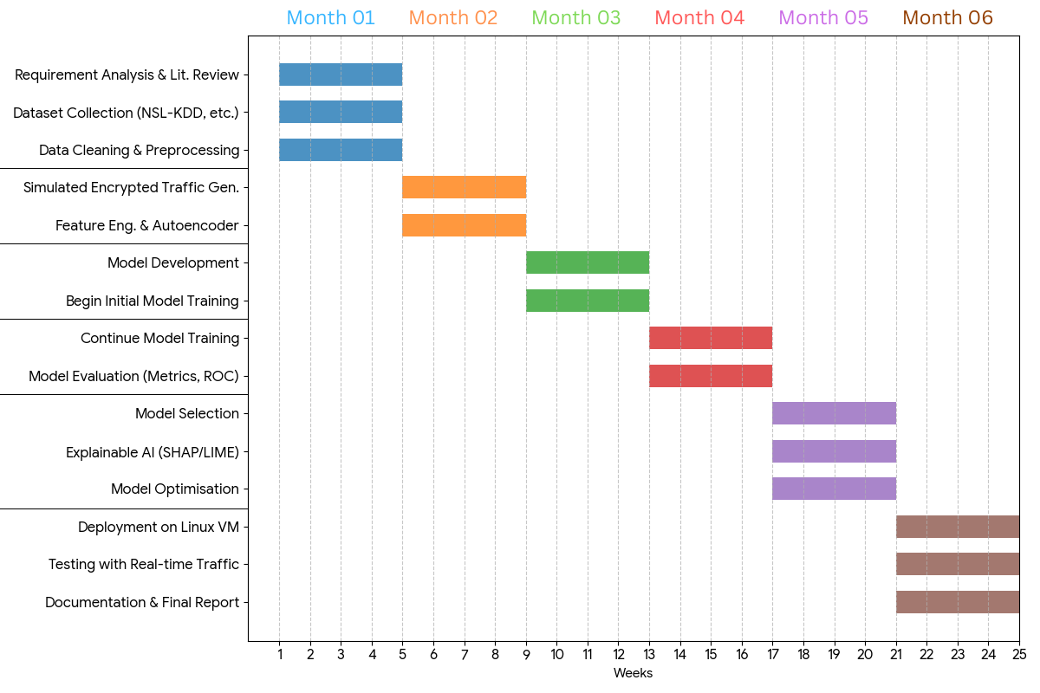
Figure 1 Gantt chart

7. Conclusion
The proposed system focuses on developing a lightweight and efficient machine learning-based intrusion detection system capable of detecting both common and rare network attacks. By using flow-level metadata, the system addresses the challenge of detecting threats in encrypted traffic without relying on payload inspection.
The integration of class balancing techniques improves detection of minority attack categories, while feature optimization ensures the system remains suitable for real-time deployment. Additionally, the use of Explainable AI enhances transparency and trust in the model’s decisions.
This project contributes a practical and efficient IDS solution aligned with modern network environments and resource constraints.

8. References

[1] M. Al Lail, A. Garcia, and S. Olivo, “Machine Learning for Network Intrusion Detection—A Comparative Study,” Future Internet, vol. 15, no. 7, p. 243, 2023.
[2] Z. Huang, Z. Li, and J. Zhang, “Enhancing network security through machine learning: A study on intrusion detection system using supervised algorithms,” Applied and Computational Engineering, vol. 19, pp. 50–66, 2023.
[3] M. Tavallaee, E. Bagheri, W. Lu, and A. A. Ghorbani, “A detailed analysis of the KDD CUP 99 dataset,” in IEEE Symposium on Computational Intelligence for Security and Defense Applications, 2009, pp. 1–6.
[6] S. Z. Rahman, “A sequential deep learning framework for a robust and resilient network intrusion detection system,” Computers & Security, vol. 144, p. 103928, 2024.
[7] R. Shetty and C. Achar, “Advanced Machine Learning Techniques used in Network-Based Intrusion Detection Systems,” IJARIIE, vol. 10, no. 3, 2024.
[8] Hnamte, M., et al., “AE + LSTM Hybrid IDS for Modern Traffic,” 2023.
[9] Canadian Institute for Cybersecurity, “CICIDS2017 dataset,” 2017. [Online]. Available: https://www.unb.ca/cic/datasets/ids-2017.html
[10] N. Moustafa and J. Slay, “UNSW-NB15: A comprehensive dataset for network intrusion detection systems,” in Military Communications and Information Systems Conference, 2015, pp. 1–6.
[11] D. Kwon, J. Kang, and S. Kim, “Handling rare attacks in network intrusion detection datasets,” IEEE Communications Letters, vol. 23, no. 6, pp. 1025–1028, 2019.
[12] Y. Liu, M. Li, and H. Jin, “Zero-day attack detection using machine learning,” Journal of Network and Computer Applications, vol. 156, pp. 102–114, 2020.
[13] NSL-KDD Dataset, “NSL-KDD dataset for network intrusion detection research,” [Online]. Available: https://www.unb.ca/cic/datasets/nsl.html
[14] T. Chen and C. Guestrin, “XGBoost: A scalable tree boosting system,” in Proc. 22nd ACM SIGKDD International Conference on Knowledge Discovery and Data Mining, 2016, pp. 785–794.
[15] Y. LeCun, Y. Bengio, and G. Hinton, “Deep learning,” Nature, vol. 521, pp. 436–444, 2015.
[16] A. Krizhevsky, I. Sutskever, and G. E. Hinton, “ImageNet classification with deep convolutional neural networks,” in Advances in Neural Information Processing Systems, 2012, pp. 1097–1105.

